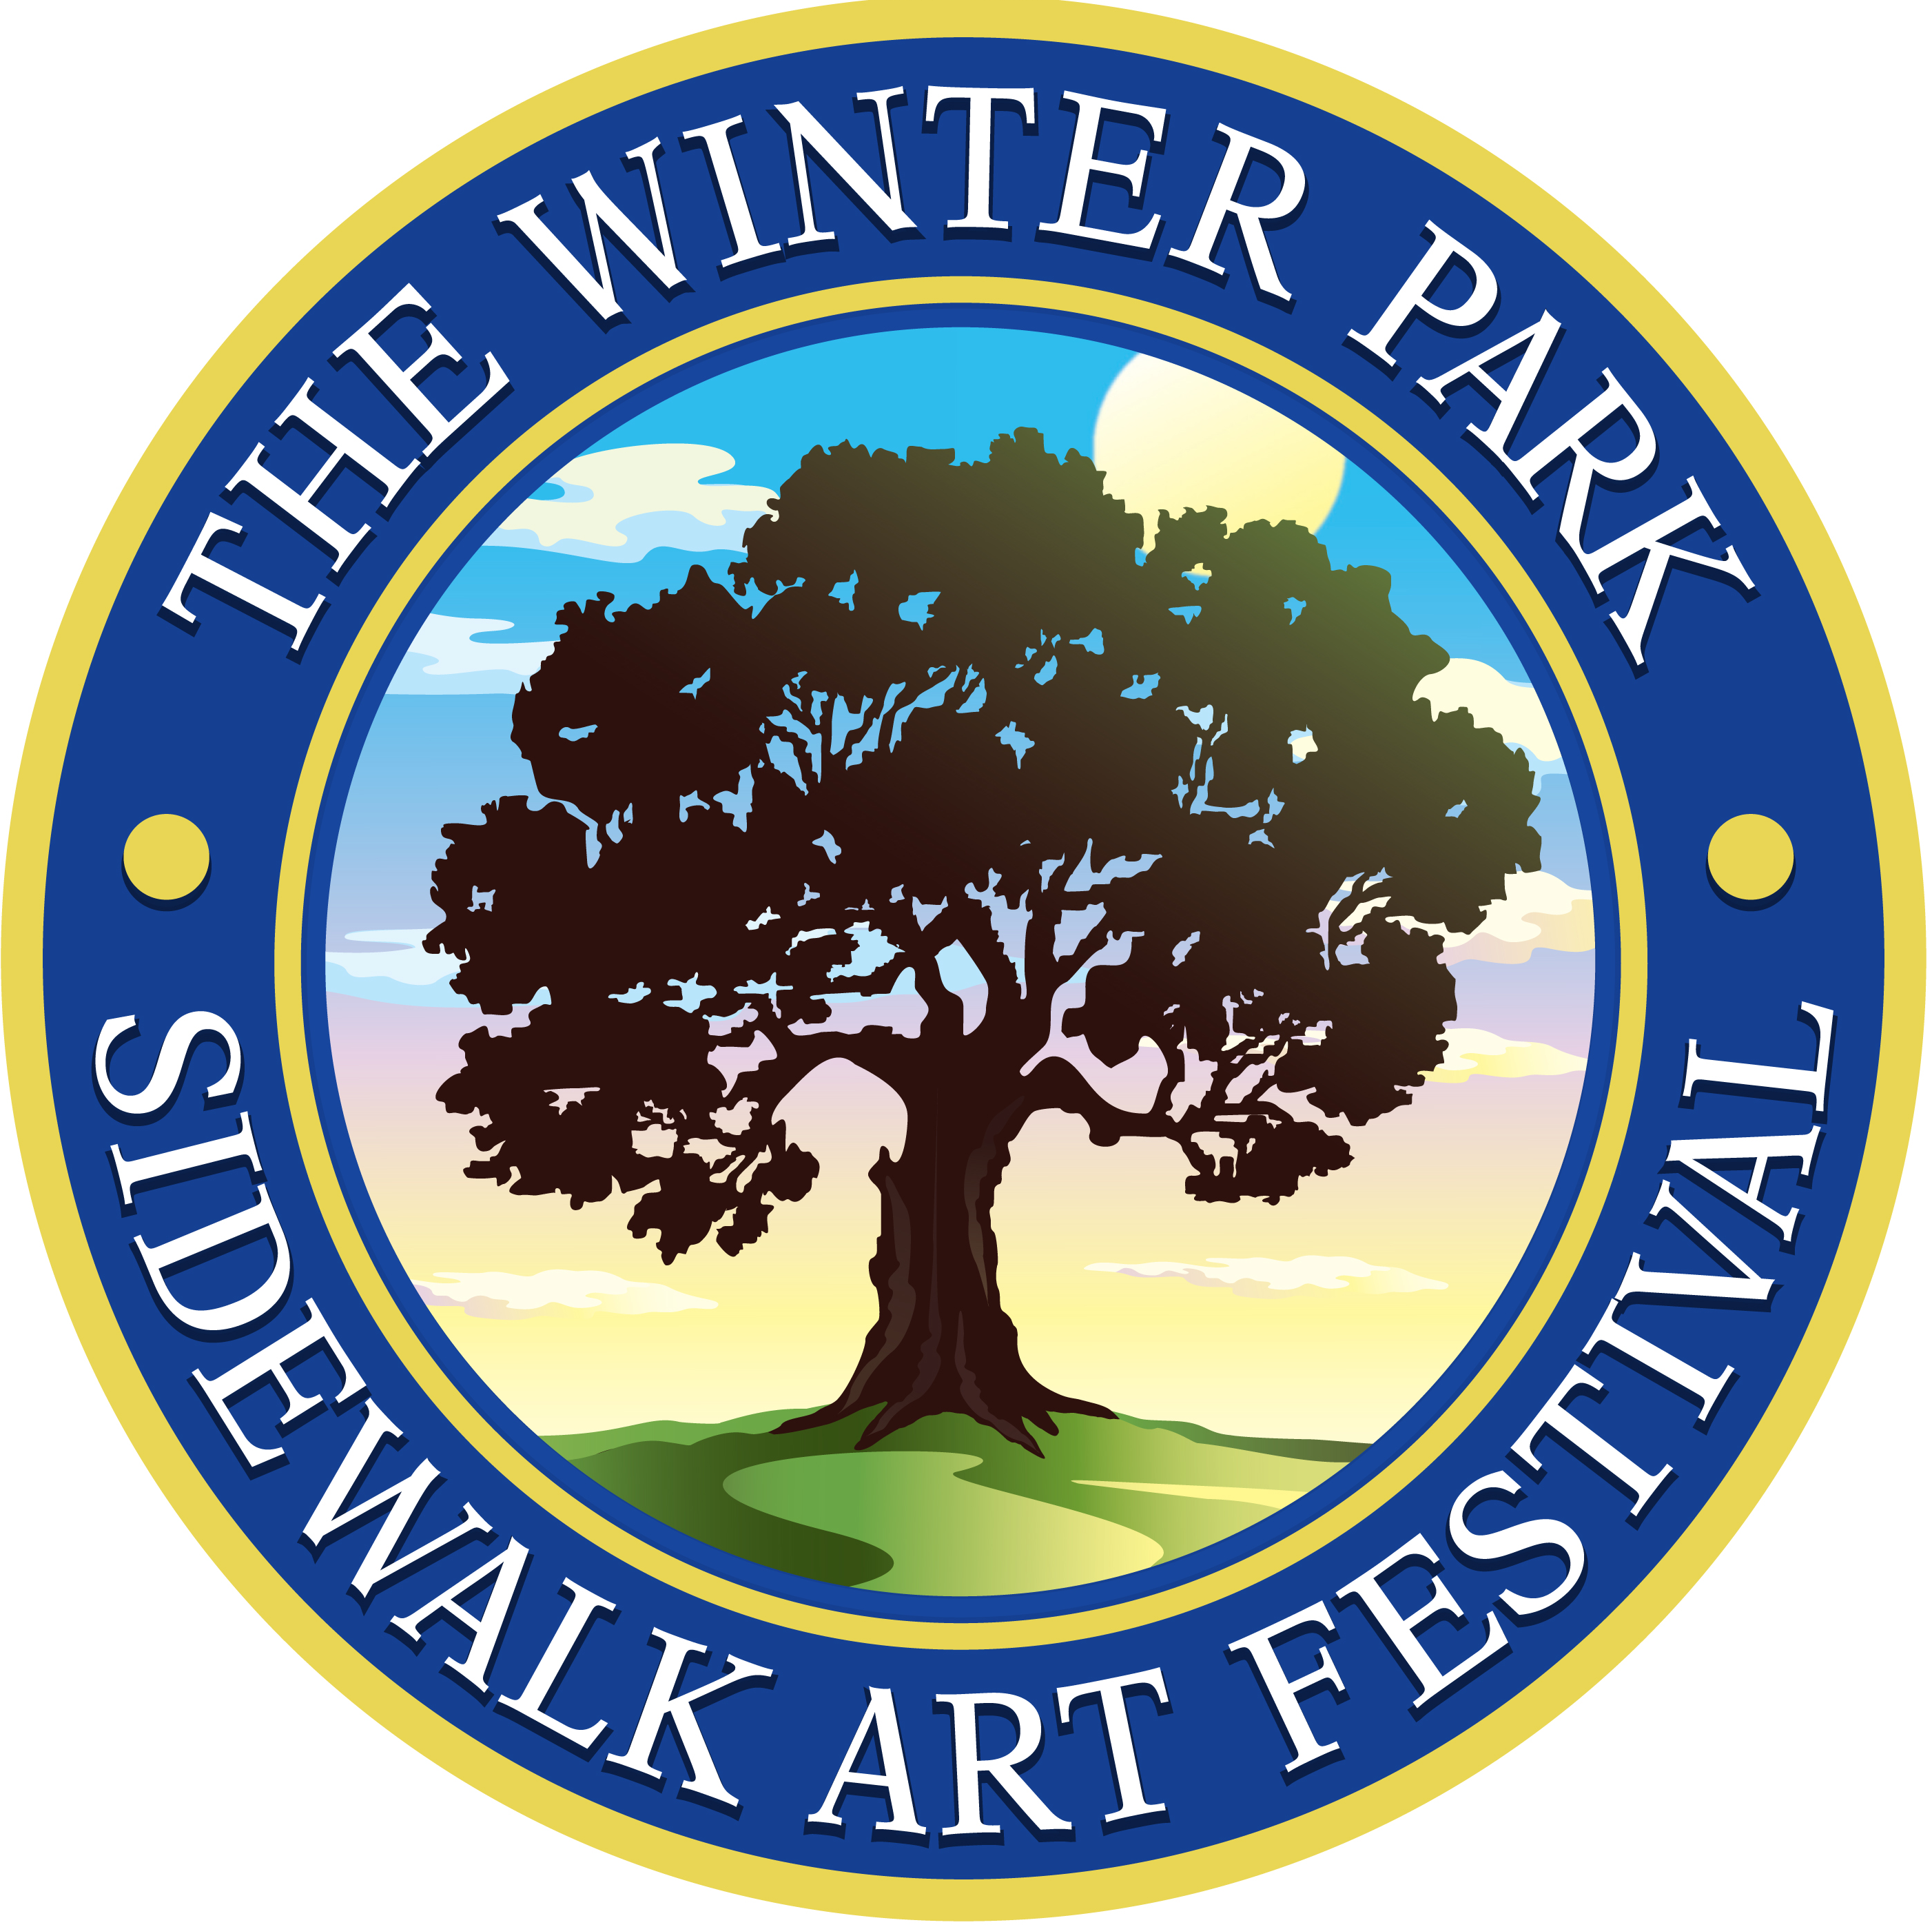

SAVE THE DATE!

THE 60th WINTER PARK
SIDEWALK ART FESTIVAL

March 15 - 17, 2019

TEACHER SETUP: 8 a.m. – 5 p.m., Thursday, March 14, 2019
BREAKDOWN: 3:30 – 4 p.m., Sunday, March 17, 2019

www.wpsaf.org schools@wpsaf.org

Teachers’ non-public website: www.wpsaf.org/schools

